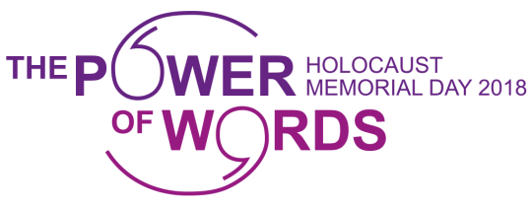
SCHOOLS BOOKING FORM

Please check and complete the details on this form.
To secure your booking, this form MUST be signed and returned to Natalie Gandy by Wednesday 17th January 2018

School name, address, tel no.

Preferred date of visit: | Number of pupils and age of pupils
Contact name: | Contact e-mail:
Time of arrival: | Lunch space required ?
Let us know of any SEND or medical needs your pupils may have – this will enable us to best meet the needs of all of the pupils during their visit:

Which free workshop(s) does your school wish to attend (please tick the relevant box below):

Freedom Writers (Year 9+)

Writing in impossible circumstances – Anne Frank – A Life and Legacy (Year 5+)

Crystal’s Vardo - Performance (Year 5+)

Note: If your school would like to attend the Self-led Exhibition Viewing, please contact Clare Rogers (Learning and Outreach Officer) at The Higgins either via telephone 01234 276335 or email clare.rogers@bedford.gov.uk.

I understand and accept that pupils are the responsibility of school staff while at The Higgins Bedford as part of an organised school visit for the Holocaust Memorial Day programme
Signed: | Date:

Please return form to:
Natalie Gandy (Democratic Services Officer) Email: natalie.gandy@bedford.gov.uk
Telephone number: 01234 228256

© Anne Frank Fonds, Basel, Switzerland

